Functional Cohesion

📌 Definition:
# Source: AI Source: Provided by: [Data Path: Persons Table -> ID Column: 1, Name_En Column: Motasem Essam] -> From: [Chatgpt (GPT‑5 Mini)] on [12/9/2025]
Functional Cohesion occurs when all elements of a class/module contribute to a single, well-defined task, making the module highly focused and purposeful.

🧠 Simple idea:
# Source: AI Source: Provided by: [Data Path: Persons Table -> ID Column: 1, Name_En Column: Motasem Essam] -> From: [Chatgpt (GPT‑5 Mini)] on [12/9/2025]
“Everything works together to perform one function” ✅

🔍 Key characteristics:
# Source: AI Source: Provided by: [Data Path: Persons Table -> ID Column: 1, Name_En Column: Motasem Essam] -> From: [Chatgpt (GPT‑5 Mini)] on [12/9/2025]
- Class/module has one clear responsibility
- ✅ Easier to maintain, test, and reuse
- ✅ Improves clarity and readability
- ✅ Promotes high reliability

📊 Example:
# Source: AI Source: Provided by: [Data Path: Persons Table -> ID Column: 1, Name_En Column: Motasem Essam] -> From: [Chatgpt (GPT‑5 Mini)] on [12/9/2025]
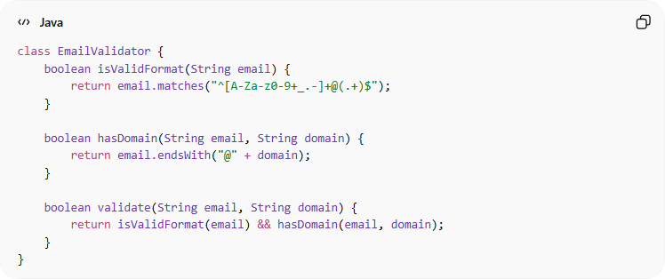
class EmailValidator {
boolean isValidFormat(String email) {
return email.matches("^[A-Za-z0-9+_.-]+@(.+)$");
}

boolean hasDomain(String email, String domain) {
return email.endsWith("@" + domain);
}

boolean validate(String email, String domain) {
return isValidFormat(email) && hasDomain(email, domain);
}
}
- ✅ All methods are focused on email validation
- ✅ No unrelated tasks in the class → functional cohesion

Functional Cohesion doesn’t usually have a “bad practice” example is because It is actually the best and most desirable type of cohesion

⚙️ Best Practice:
# Source: AI Source: Provided by: [Data Path: Persons Table -> ID Column: 1, Name_En Column: Motasem Essam] -> From: [Chatgpt (GPT‑5 Mini)] on [12/9/2025]
- Design classes/modules around a single, specific function
- Keep methods related to that function
- Avoid adding unrelated responsibilities
- Functional cohesion improves maintainability, testability, and modularity

